SECONDARY



JHS

LEARNING STRAND 1

COMMUNICATION SKILLS IN ENGLISH

MODULE 3: I MYSELF BELIEVE (EXPRESSING OPINIONS)

ALS Accreditation and Equivalency Program: Junior High School

LEARNING STRAND 1

I MYSELF BELIEVE



EXPRESSING OPINIONS

#### COMMUNICATION SKILLS IN ENGLISH MODULE 3

**ALS Accreditation and Equivalency Program:** Junior High School

**Learning Strand 1:** Communication Skills in English

**Module 3:** I Myself Believe (Expressing Opinions)

Published in 2020 by the United Nations Educational, Scientific and Cultural Organization UNESCO Office, Jakarta

Jalan Galuh II No. 5, Kebayoran Baru, Jakarta, Indonesia

*and*

Department of Education

DepEd Complex, Meralco Avenue, Pasig City, Philippines Copyright © UNESCO and DepEd 2020

This publication is available in Open Access under the Attribution-Share Alike 3.0 IGO (CC-BY-SA) 3.0 IGO) license [(h](http://creativecommons.org/licenses/by-sa/3.0/igo/))t[tp://creativecommons.org/licenses/by-sa/3.0/igo/).](http://creativecommons.org/licenses/by-sa/3.0/igo/)) By using the content of this publication, the users accept to be bound by the terms of use of the UNESCO Open Access Repository (http://www.unesco. org/open-access/terms-use-ccbysa-en).

The designations employed and the presentation of material throughout this publication do not imply the expression of any opinion whatsoever on the part of UNESCO concerning the legal status of any country, territory, city or area or of its authorities, or concerning the delimitation of its frontiers or boundaries.

The selection and presentation of the material contained in this publication, as well as the opinions expressed herein are the sole responsibility of the authors and not necessarily those of UNESCO, nor do they commit the organization in any way.

This educational resource material was developed and printed through the project “Better Life for Out-of- School Girls to Fight Against Poverty and Injustice in the Philippines” with financial support from Korea International Cooperation Agency (KOICA).

Printed by APC Printers Corporation Printed in Makati City, Philippines

ISBN 888-888-8888-88-8

DEVELOPMENT TEAM



**Jenelyn Marasigan Baylon Kristine Lee S. Lumanog**

**Judy R. Mendoza Reyangie V. Sandoval Josephine C. Intino**

**Eric U. Labre Roderick P. Corpuz**

**Daisy Asuncion O. Santos Marilette R. Almayda**

**Ariz Delson Acay D. Cawilan**

**G. H. S. Ambat Tonisito M. C. Umali Leonor Magtolis Briones**



**Jaime Daroy Elizabeth Reyes Bernadette Sison Mildred Parbo**

**Ma. Teresita Medado**

Master Teacher I, ALS Task Force (On-detail)

Education Program Specialist II, ALS Task Force (On-detail) Project Development Officer III, Bureau of Learning Resources Education Program Specialist II, Bureau of Learning Resources

Senior Education Program Specialist, Bureau of Curriculum Development Senior Education Program Specialist, Bureau of Learning Resources Supervising Education Program Specialist, ALS Task Force

Chief Education Program Specialist, Bureau of Learning Resources Director III/Head, ALS Task Force

Officer-In-Charge, Office of the Director IV, Bureau of Learning Resources Assistant Secretary for Alternative Learning System Program

and Task Force

Undersecretary for Legislative Liaison Office, External Partnership Service and Project Management Service

Secretary

Author Content Expert

Admin and Finance Staff Project Lead

President

**Content and Language Evaluators and Instructional Design Reviewer**

**Marlon P. Daclis Tuesday C. De Leon Olivia G. Torres**

Schools Division Office of San Jose City, Department of Education Pangasinan State University

Schools Division Office of Bulacan, Department of Education



**Ade Sandra Rusyda Djamhur**

**Marmon Abutas Pagunsan Remegio Alquitran**

**Maria Karisma Bea Agarao**

**Mee Young Choi Shahbaz Khan**

Admin and Finance Assistant Project Assistant

National Project Consultant National Project Officer

National Programme Coordinator Head of Education Unit

Director and Representative

**User’s Guide**



***For the ALS Learner:***

Welcome to this Module entitled I Myself Believe (Expressing Opinions) under Learning Strand 1 Communication Skills in English of the ALS K to 12 Basic Education (BEC).

This module was designed to provide you with fun and meaningful opportunities for guided and independent learning at your own pace and time. You will be enabled to process the contents of the learning resource while being an active learner.

This module has the following parts and corresponding icons:



|  |  |
| --- | --- |
| ***Let’s Get to Know*** | This will give you an idea of the skills or competencies you are expected to learn in the module. |
| ***Pre-assessment*** | This part includes an activity that aims to check what you already know about the lesson. If you get all the answers correct (100%), you may decide to skip this module. |
| ***Setting the Path*** | This section provides a brief discussion of the lesson. This aims to help you discover and understand new concepts and skills. |
| ***Trying This Out*** | This comprises activities for independent practice to solidify your understanding and skills of the topic. You may check the answers to the exercises using the Answer Key at the end of the module. |
| ***Understanding What You Did*** | This includes questions that process what you learned from the lesson. |
| ***Sharpening Your Skills*** | This section provides an activity that will help you transfer your new knowledge or skill in real-life situations or concerns. |
| ***Treading the Road to Mastery*** | This is a task which aims to evaluate your level of mastery in achieving the given learning competency. |
| ***Don’t Forget*** | This part serves as a summary of the lessons in the module. |
| ***Explore More*** | In this portion, another activity will be given to you to enrich your knowledge or skill of the lesson learned. This also tends retention of learned concepts. |
| ***Reach the Top*** | This part will assess your level of mastery in achieving the learning competencies in each lesson in the module. |
| ***Answer Key*** | This contains answers to all activities in the module. |
| ***Glossary*** | This portion gives information about the meanings of the specialized words used in the module. |

At the end of this module you will also find:

|  |  |
| --- | --- |
| ***References*** | This is a list of all sources used in developing this module. |

The following are some reminders in using this module:

1. Use the module with care. Do not put unnecessary mark/s on any part of the module. Use a separate sheet of paper in answering the exercises.
2. Don’t forget to answer the Pre-assessment before moving on to the other activities included in the module.
3. Read the instruction carefully before doing each task.
4. Observe honesty and integrity in doing the tasks and checking your answers.
5. Finish the task at hand before proceeding to the next.
6. Return this module to your ALS Teacher/Instructional Manager/Learning Facilitator once you are through with it.

If you encounter any difficulty in answering the tasks in this module, do not hesitate to consult your ALS Teacher/Instructional Manager/Learning Facilitator. Always bear in mind that you are not alone.

We hope that through this material, you will experience meaningful learning and gain deep understanding of the relevant competencies. You can do it!

CONTENTS

|  |  |
| --- | --- |
| **Let’s Get to Know** | 1 |
| **Pre-Assessment** | 2 |
| **LESSON 1: What is the Subject, Please?** | 3 |
| Setting the Path | 3 |
| Trying This Out | 4 |
| Understanding What You Did | 5 |
| Sharpening Your Skills | 9 |
| Treading the Road to Mastery | 10 |
| **LESSON 2: It’s Simply Active** | 11 |
| Setting the Path | 11 |
| Trying This Out | 12 |
| Understanding What You Did | 13 |
| Sharpening Your Skills | 22 |
| Treading the Road to Mastery | 23 |
| **LESSON 3: You Are So Intense** | 24 |
| Setting the Path | 24 |
| Trying This Out | 25 |
| Understanding What You Did | 26 |
| Sharpening Your Skills | 33 |
| Treading the Road to Mastery | 34 |

CONTENTS

|  |  |
| --- | --- |
| **Don’t Forget** | 35 |
| **Explore More** | 36 |
| **Reaching the Top** | 37 |
| **Answer Key** | 38 |
| **Glossary** | 43 |

## LET’S GET TO KNOW



E

ffective speaking skills, like reading and listening, do not come naturally to most people. This means one has to work on these skills consciously

in order to become better at them. Reading does not just involve the eyes, nor does listening just involve the ears. Likewise, speaking is not just about moving the mouth. In other words, speaking, reading, and listening are a whole body experience.

This module on speaking is divided into two parts. The first part involves a discussion of the types of sentences according to structure, particularly the *simple sentence* and the *compound sentence*.

The second part deals with the *rules on subject-verb agreement* which govern the construction of basic sentences such as the simple sentence.

Furthermore, this module also includes a discussion of the use of the **active and passive voice** of the verb; the **object**; the use of **reflexive and intensive pronouns**; and lastly, how to express **opinions** using some common start-up phrases.



PRE-ASSESSMENT

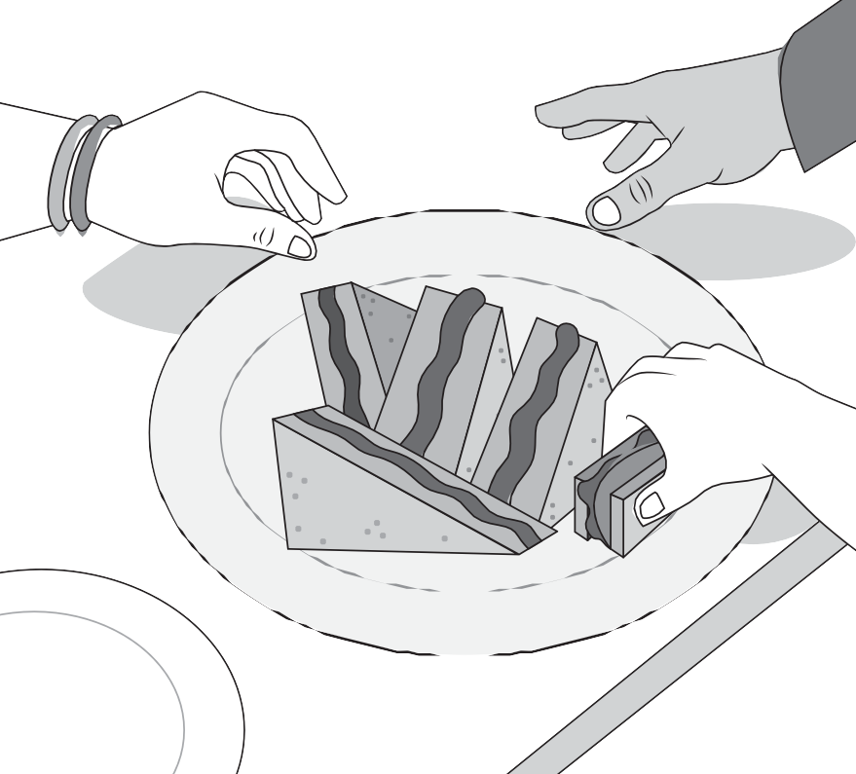

Which is better: “*I ate the sandwich*”, or “*The sandwich was eaten by me*”? Is it “*I saw you*”, or “*You were seen by me*”? Well, strictly speaking, they are all grammatically correct.

However, let’s not talk of grammar, or the proper way of putting words together to form a meaningful sentence. Instead, let us focus on the **impact** of a sentence.

Which has a stronger effect? Which has a greater impact: *I ate the sandwich*? Or *the sandwich was eaten by me*? What do you think?

SETTING THE PATH



# WHAT IS THE SUBJECT, PLEASE?

At the end of this lesson, you will be able to:

observe correct subject/verb agreement; (LS1CS/EN-S-PSB-JHS-54);

describe/explain what subject is (LS1CS/EN-S-PSB-JHS-00); and

observe subject-verb agreement in a sentence (LS1CS/EN-S-PSB-JHS-54).



TRYING THIS OUT

Write your answers on a separate sheet of paper.

* 1. Identify the subject and the verb in each of the following sentences.
     1. Anger increases the risk of a heart attack.
     2. At 10, Fred already learned how to play the guitar.
     3. Time is as precious as gold.
     4. The newly registered voters exercise their right to vote.
     5. I am excited to see our new teacher.
  2. Which of the following statements are true and which ones are false? Write **T** if a statement conveys a truth and write **F** if it conveys a falsity.
     1. The subject-verb agreement states that subjects and verbs must agree with each other in number.
     2. A singular subject takes a plural verb.
     3. A plural subject takes a singular verb.
     4. A singular subject takes a singular verb.
     5. A plural subject takes a plural verb.

The subjects in the above sentences are: A*nger, Fred, Time, The newly registered voters,* and *I*, and the verbs used for those subjects are: *increases, was, is, exercise,* and *am*. In order to form grammatically correct sentences, the agreement between the subject and the verb of the sentence must be observed. The basic rule on subject-verb states that the subject of a sentence and its verb must agree in number. Therefore, if the subject of the sentence is singular, the verb should also be singular. If the subject of the sentence is plural, the verb should also be plural.

## UNDERSTANDING WHAT YOU DID



SUBJECT

VERB

#### THE SUBJECT AND THE VERB

All sentences must have a subject and a verb.

***Deflnition of Subject and Verb:***

**·**

**·**

The **subject** is the person or thing that does something, or that is described in a sentence.

The **verb** is the action the person or thing takes, or the description of the person or thing (as part of the predicate).

Examples:

* + - * **We** (subject) **walk** (verb) to school every day.
      * The **sun** (subject) **rises** (verb) in the east.
      * **You** (subject) **won** (verb) easily!

ACTIVITY

**Directions:** Identify the subject and the verb in the following sentences. Write your answers on a piece of paper.

1. Helping others is a good thing.
2. I believe in both hard work and fortune.
3. They are in the park walking the dog.
4. We are here to help you.
5. Do you want to go out for a walk?
6. Disagreement is a part of communication.
7. The girls are having fun.
8. I win the game every time.
9. The game is far from over.
10. You better believe it.

#### SUBJECT-VERB AGREEMENT



Subject-verb agreement: This is a grammar rule that states that subjects and verbs must agree with each other in number.

**·** The child plays at the park. (Singular)

**S V**

**·**

The children play at the park. (Plural)

**S V**

###### BASIC SUBJECT-VERB AGREEMENT RULES

· A singular noun (SN) needs a singular verb (SV).

The child plays at the park.

**SN SV**

**·**

A plural noun (PN) needs a plural verb (PV).

The children play at the park.

**PN PV**

### LESSON 1

Listening to how a language sounds is just as important as knowing how it is structured.

Can you make the subject and the verb agree in number in the following sentences? Let’s do it:

INCORRECT CORRECT

The boy sing very well.

The boys plays basketball every day.

We is here to support you They wants to sing you a song.

She like you.

The boy sings very well.

The boys play basketball every day.

We are here to support you. They want to sing you a song.

She likes you.

Did you notice that we changed the verbs?

The subject **Boy** is a singular noun and it needs the singular verb, **sings**. The subject **Boys** is a plural noun and it needs the plural verb, **play**.

The subject **We** is a plural pronoun and it needs the plural verb, **are**. The subject **They** is a plural pronoun and it needs the plural verb, **want**.

The subject **She** is a singular pronoun and it needs the singular verb, **likes**.

Verbs are singular in number if they are in the –s/-es form. Plural verbs, on the other hand, are in the base form. See the table that follows.

|  |  |  |
| --- | --- | --- |
| TYPES OF VERBS | SINGULAR  (-s/-es form) | PLURAL  (base form) |
| Be Verbs | is, was | are, were |
| Have Verbs | has | have |
| Action Verbs | goes | go |
| dances | dance |
| flies | fly |
| moves | move |
| thinks | think |



description of the person or thing.

* The **basic rule on subject-verb agreement** states that the subject and its verb must agree with each other in number.

or that is described in the sentence.

* The **verb** is the action the person or thing takes, or the

**Understanding What You Did**

* The **subject** is the person or thing that does something,

## SHARPENING YOUR SKILLS

Write your answers on a separate sheet of paper.

**I.** Choose which of the verbs inside the parentheses agrees with the subject in the following sentences.

1. Trees (help/helps) prevent flooding.
2. She (like/likes) to recite in class.
3. Lions (live/lives) in groups called prides.
4. They (see/sees) things that we do not.
5. Annaliza (is/are) the first to arrive in class.
6. We (play/plays) mobile games most of the time.
7. He (do/does) not like to be the first to give the speech.
8. No, I (do/does) not want to see your project.
9. To many people, peace (is/are) simply the absence of war.
10. Suddenly, a number of vloggers (has/have) mushroomed in social media.



TREADING THE ROAD TO MASTERY

**Directions:** Read the short paragraph below and create a table which shows the subject and the verb of each of the sentences. Write your answers on a separate sheet of paper.



**Hello!**

My elder sister likes to talk to her friends on the phone in the afternoons. They talk for hours on end without skipping an afternoon in a month. My father thinks she needs this time to get away from her chores.

SETTING THE PATH



# IT’S SIMPLY ACTIVE

At the end of this lesson, you will be able to:

differentiate a simple sentence from a compound sentence (LS1CS/EN-S-PSB-AE/JHS-50);

use compound sentences to show relationship of ideas (LS1CS/EN-S-PSB-AE/JHS-50);

write simple sentences and compound sentences (LSICS/EN-W-PSE-JHS-5); and

use the passive and active voice meaningfully in varied contexts (LS1CS/EN-S-PSB-JHS-55).



TRYING THIS OUT

Write your answers on a separate sheet of paper.

1. Identify whether the sentence is **simple** or **compound.**
   1. They are working for the school.
   2. These workers do well, but they are paid too little.
   3. These problem may seem small, yet they are real.
   4. People must think of a solution.
   5. We need the help of everyone.
2. Identify whether the sentence is in the active or passive voice.
   1. They watch the movie together.
   2. Noel was brought up by his grandparents.
   3. Everyone had arrived and started to warm up.
   4. The music was being played by the student band.
   5. The project was spearheaded by the student council officers.

To tell the difference between a **simple sentence** and a **compound sentence**, count the number of *independent clauses* that there is/are in a sentence. An **independent clause** is a clause that can stand alone as a sentence. A simple sentence consists of *only one* independent clause. A compound sentence, on the other hand, has *at least two* independent clauses.

## UNDERSTANDING WHAT YOU DID





##### SENTENCES: Simple and Compound

Basically, there are four kinds of sentences according to structure. These are the **simple sentence**, the **compound sentence**, the **complex sentence**, and the **compound complex sentence.** In this particular lesson, however, we will just be focusing on the simple and the compound sentences.

#### SIMPLE SENTENCE

A **simple sentence** is composed of a single independent clause. An **independent clause** is a group of words that has a subject and a verb and expresses a complete thought. It can stand alone as a sentence.

**·**

She greets everyone with a smile.

**·**

The issue was brought to our concern.

**·**

To succeed in life, one must work really hard. Climate change is a serious global problem.

**·**

**·**

His speech has inspired all of us to be diligent in our studies.

Can you identify the subject and the verb in the sentences? For the purpose of analyzing the sentences, we will use the following abbreviations: **S –** Subject and **V –** Verb.

**LET US TRY**

**·**

**·**

**·**

**·**

**·**

She greets everyone with a smile.

**S**

**V**

The issue was brought to our concern.

**S**

**V**

To succeed in life, one must work really hard.

**S**

**V**

Climate change is a serious global problem.

**S**

**V**

His speech has inspired all of us to be diligent in our studies.

**S**

**V**

#### COMPOUND SENTENCE

A **compound sentence** is made

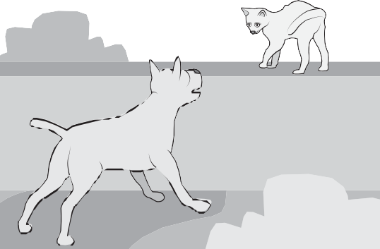up of two or more independent clauses connected by a coordinating conjunction such as *for, and, nor, but, or, yet, so.*

*The dog barks wildly and the cat simply stares without care.*

This compound sentence consists of two independent clauses connected by the conjunction and.

*The dog barks wildly and the cat simply stares without care.*

and

*the cat simply stares without care*

*The dog barks wildly*

coordinating conjunction

Another example is given below.

*Elephants are the largest land mammals, but they are gentle animals.*

but

*they are gentle animals*

*Elephants are the largest mammals*

independent clause (IC)

coordinating conjunction (CC)

independent clause (IC)

More Examples of Compound Sentences

Compound sentences contain related ideas.

Suddenly, the rain poured hard, and everyone rushed to their homes.

IC CC IC

Marvin is fond of musical instruments, but his brother Nilo is not.

IC CC IC

He is a famous movie star, yet he is very humble.

IC CC IC

None of my siblings wanted to leave our house, so I went to the mall sales

alone. IC

CC IC

Jane is not permitted to play outside of their house, nor is she allowed to talk

with strangers. IC

CC IC

As you may have noticed, a comma (,) is used before the coordinating conjunction that connects the independent clauses.

#### ACTIVE VOICE AND PASSIVE VOICE



SUBJECT

+ VERB

OBJECT

+ VERB

+ SUBJECT

+ OBJECT

##### What is the Active Voice?

When the subject of a sentence performs the action of the verb, we say that the sentence is in the **active voice.** Sentences in the active voice have a strong, direct, and clear tone. Here are some short and simple examples of sentences written in active voice.

The vendor sells bananas.

**S**

(Who sells bananas? The vendor.)



The bus conductor counted the money.

**S**

(Who counted the money? The bus conductor.)

Mom mended my broken shoes.

**S**

(Who mended my broken shoes? Mom)

The orchestra played classical music to the delight of the audience.

**S**

(Who played classical music to the delight of the audience? The orchestra.)

The Bantay Paligid conducts a weekly clean up drive.

**S**

(Who conducts a weekly clean up drive? The Bantay Paligid.)

We have talked about the *subject* and the *verb.* Now let us discuss the *object* of the sentence*.* The **object** is the receiver of the action (transitive verb) performed by the subject. The **transitive verb** is usually used in sentences which employ the active voice. A transitive verb must always have an object.

Let’s identify the subject, verb, and object in these sentences.

**SAMPLE SENTENCES**

1. The **vendor** sells ***bananas.***

**S V O**

1. The **bus conductor** counted the ***money.***

**S V O**

1. **Mom** mended my broken ***shoes.***

**S V O**

1. **The orchestra** played classical ***music*** to the delight of

**S**

the audience.

**V**

**O**

**5. The Bantay Paligid** conducts a weekly ***clean-up drive.***

**S V O**

All these sentences have a basic active voice construction: ***subject, verb,*** and ***object.*** The subject *vendor* performs the action of *selling.* The subject *bus conductor* performs the action of *counting*. The subject *Mom* performs the action of *mending.* The subjects are the doers/performers of the actions in the sentences.

ACTIVITY

**Directions:** Identify the object in the sentences. Write your answers on a separate sheet of paper.

1. The waitress accidentally dropped the glass.
2. I saw someone outside the window last night.
3. We drove my car to the mall yesterday.
4. The chef prepared a special dish for them.
5. Leila received an email from her poster parents..

##### What is the Passive Voice?

The passive voice focuses on the **object** and the **action** taken on it, not on the one *who did* or *is doing the action.*

ACTIVE VOICE PASSIVE VOICE

The vendor sells bananas.

**S V O**

The bus conductor counted

**S V**

the money.

**O**

**Bananas are sold** by the vendor.

The **money was counted** by the bus conductor.

ACTIVE VOICE PASSIVE VOICE

Mom mended my broken

**S V**

shoes.

**O**

The orchestra played classical

**S V**

music to the delight of the

**O**

**My broken shoes were mended** by my Mom.

**Classical music was played** by the orchestra to the delight of the audience.

audience.

The Bantay Paligid conducts

**S V**

a weekly clean-up drive.

**O**

**A weekly clean-up drive is conducted** by the Bantay Paligid*.*

Although the active voice has more **impact**, the passive voice is not necessarily wrong nor should it be avoided.

The passive voice may be used in cases where the *object and action are emphasized*, rather than the doer. When transforming a sentence from active to passive voice, the object must be placed in the position of the subject followed by an auxiliary verb (the tense carrier) and a main verb in its past participle form.

ACTIVE VOICE PASSIVE VOICE

The player passed the ball. The ball is passed by the player.

S V O

AUXILIARY VERB + MAIN VERB (TENSE CARRIER)

Examples:





Active Voice

The wedding planner is making all the reservations.

Passive Voice

All the reservations are being made by the wedding planner.

Active Voice

The cat carried her kitten in her mouth.

Passive Voice

The kitten was carried by the cat in her mouth.

Active Voice

The science class viewed the comet.

Passive Voice

The comet was viewed by the science class.

Active Voice

The class facilitator will give you Directions.

Passive Voice

Directions will be given to you by the class facilitator.

Active Voice



The saltwater corroded the metal beams.

Passive Voice

The metal beams were corroded by the saltwater.

ACTIVITY

**Directions:** Transform the following sentences from **active voice**

into **passive voice.** Write your answers on a separate sheet of paper.

1. Benito changed the flat tire.
2. We plant bamboo trees along the watershed.
3. We are going to watch a movie tonight.
4. My mother read the newspaper quickly.
5. I will clean the house every Saturday.



**Understanding What You Did**

* A **simple sentence** is composed of one independent
* A **compound sentence** is made up of two or more independent clauses connected by coordinating conjunctions.

clause.

* A sentence is in the **active voice** when the subject
* A sentence is in the **passive voic**e when the focus is on the object and the action taken on it.

performs the **action of the verb.**

## SHARPENING YOUR SKILLS

Write your answers on a separate sheet of paper.

1. Complete the following compound sentences.
2. You can come here and watch the show with us, or …
3. She kept redoing her homework, but …
4. You can do it this way, or …
5. We were so noisy in class, but …
6. He is now a famous celebrity, yet …
7. Transform the following sentences from active voice to passive voice.
8. We saw the movie yesterday.
9. My uncle drove the passenger jeepney today.
10. I love you.
11. Henry kept his cellphone in the drawer.
12. She took her breakfast early.



TREADING THE ROAD TO MASTERY

**Directions:** Tell whether the sentence is simple or compound. On a separate sheet of paper, write **SS** if the statement is a simple sentence and **CS** if it is compound sentence.

* 1. The surprise party was a huge success.
  2. Everyone was invited, and it lasted for hours on end.
  3. The food was great, yet we ran out of drinks fast.
  4. Jennie was really shocked so it made the scene all the better.
  5. We hope to throw another party for our friends soon!



SETTING THE PATH



# YOU ARE SO INTENSE

At the end of this lesson, you will be able to:

use reflexive and intensive pronouns (LSICS/ EN-S-PSB-JHS-27);

define and explain reflexive and intensive pronouns (LSICS/ EN-S-PSB-JHS-27); and

express ideas, opinions, and feelings about others’ ideas/on text listened to (LSICS/EN

-S-PSB/JHS-13).



TRYING THIS OUT

Write your answers on a separate sheet of paper.

1. Identify whether the following underlined words are reflexive or intensive pronouns
   1. She accidentally hurt herself during the final match.
   2. The plant itself pollinates.
   3. I myself am a recipient of his good deeds.
   4. The applicants blamed themselves for failing to beat the deadline.
   5. The victim himself reported the incident to the police.
2. Explain your answers to the following questions.
   1. Do you think dogs make better pets than cats?
   2. Do you believe in the effectiveness of virgin coconut oil?
   3. Should senior citizens get even bigger discounts?

*Herself, himself, themselves, ourselves,* and *itself* are considered as **both** reflexive and intensive pronouns. However, we will differentiate them in the following lesson, since they are still not the same. Now, whether you think dogs make better pets than cats, or whether senior citizens should get even bigger discounts, is not the main consideration here. What counts is that there are suggested ways or there are start-up phrases in expressing what you think of dogs and cats, about seniors and bigger discounts, and on virgin coconut oil. With that said, let’s begin the lesson.

## UNDERSTANDING WHAT YOU DID

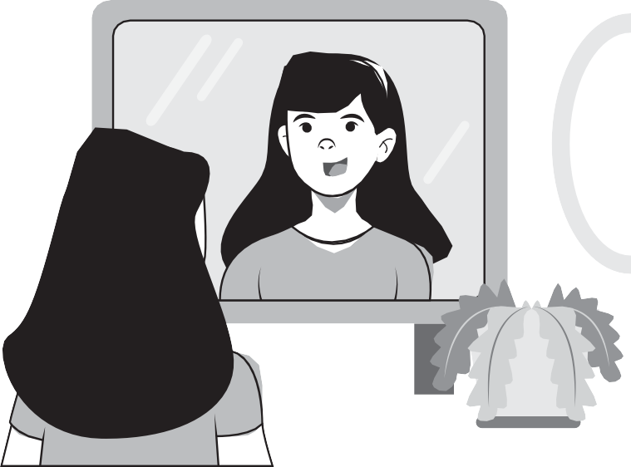

#### REFLEXIVE PRONOUN

A **reflexive pronoun** tells us that whoever performs the action in a sentence is also the one on the receiving end of that action. In other words, the reflexive pronoun reflects the action of the verb back to the subject. Think of reflexive as a reflection, the image in the mirror that bounces back to you.

**EXAMPLES**

**·**

**·**

Maria groomed herself in front of the mirror.

**N**

**RP**

When I feel upset, I console myself by listening to music.

**PP**

**RP**

N - noun PP - personal pronoun RP - reflexive pronoun

In the first example, the subject *Maria* is the object of the verb groomed.

Who groomed herself? The answer to that question is Maria.

In the second example, you will see that the subject *I* which is a pronoun is also the receiver of the action word console.

***Singular vs Plural Reflexive Pronouns:***

|  |  |
| --- | --- |
| SINGULAR | PLURAL |
| Myself | Ourselves |
| Yourself | Yourselves |
| Himself | Themselves |
| Herself | Themselves |
| Itself | Themselves |

#### INTENSIVE PRONOUN

An **intensive pronoun** emphasizes a preceding noun. Think of intensive as intense. Something intense is very strong. Intensive pronouns look exactly the same as reflexive pronouns, but they are only used for emphasis.

Consider these examples:

The President himself made the call to the

**N IP**

house speaker.

The evacuees themselves decided to leave their homes.

**N IP**

In the first example, *himself* refers to the President which is the subject of the sentence. Using an intensive pronoun tells the reader (or listener) that it is important that the President himself was the one who made the call, and not the press secretary, his executive assistant, or anybody else.

Similarly, in the second example, *themselves* refers to the subject the *evacuees*. The intensive pronoun emphasizes that the evacuees themselves and not other people decided to leave their homes.

###### Removing Intensive Pronouns

Intensive pronouns are used only for emphasis. They can be removed from a sentence without affecting its meaning. The same is not true of reflexive pronouns, which do cause a change in meaning when removed from a sentence.

WITHOUT INTENSIVE/ REFLEXIVE PRONOUNS

WITCHOINRTREENCSTIVE/ REFLEXIVE PRONOUNS

The driver gave the change.

Gary congratulated for passing the BAR.

The driver (himself) gave the change.

Gary congratuled himself for passing the BAR.

Some Common Errors in the Use of Intensive Pronouns

INCORRECT CORRECT

Andrew and myself will conduct today’s meeting.

Myself will conduct today’s meeting.

Andrew and I will conduct today’s meeting.

I will conduct today’s meeting.

INCORRECT CORRECT

You may submit your assignment to herself or myself.

You may submit your assignment to her or me.

Bear in mind that **intensive pronouns** can not function as personal pronouns (I, her, me); therefore, they cannot take the position of a subject (Andrew and *I*) and an object (to *her* or *me*) in a sentence. Intensive pronouns can only be used to emphasize the noun to which it refers.

ACTIVITY

**Directions:** Supply the correct reflexive or intensive pronouns in the following sentences. Write your answers on a separate sheet of paper.

1. I will look into the problem.
2. Why don’t you buy some candies?
3. They know better than we do.
4. Why don’t we just enjoy today?
5. She sees in you.

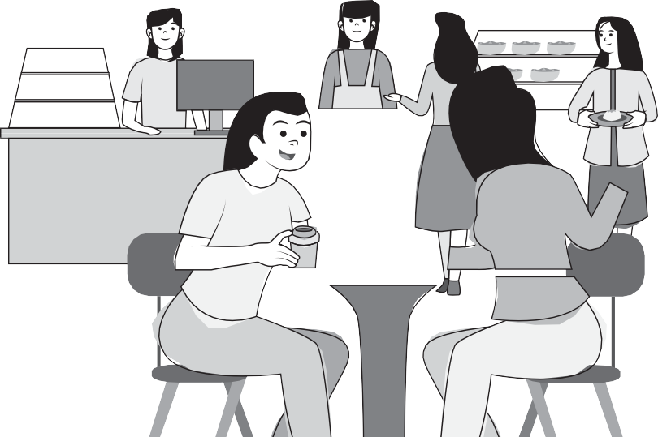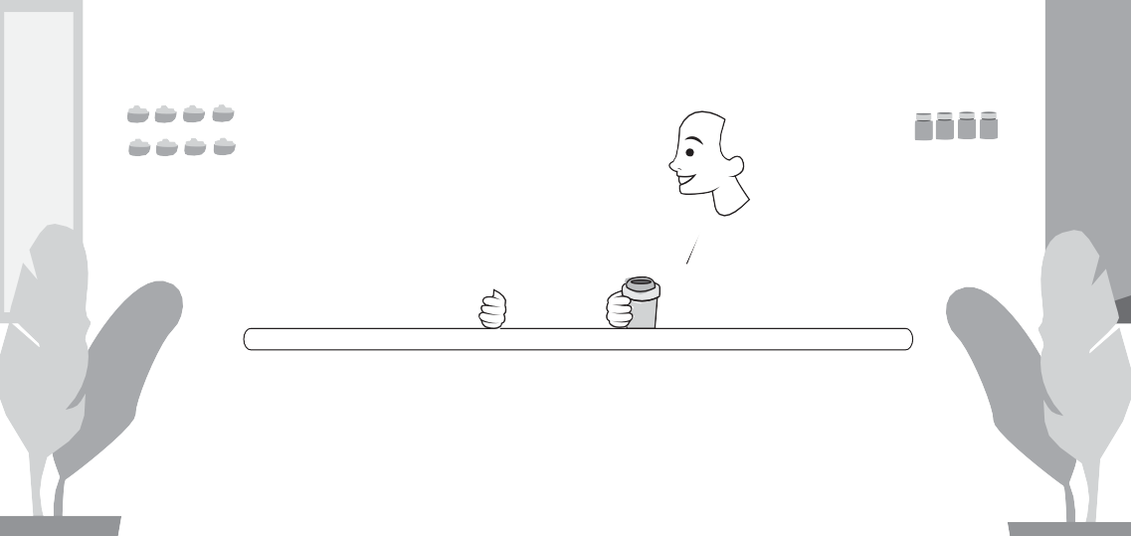

#### EXPRESSING YOUR OPINION

We will look at **common phrases** you can use to share your point of view. Many phrases are suitable in everyday speech and in some types of writing, such as on *blogs* and *personal websites.* You have probably already seen or used some of these phrases:

* *I think…*

*I think* we should give drivers more training to lessen road accidents.

* *I believe…*

This, *I believe,* is a better option than the one he suggested.

* *I feel…*

*I feel* that it would be impossible to give in to their request.

* *In my opinion…*

*In my opinion,* we should start moving while it’s still early.

* *I would say…*

We would get there, I would say, by around 10 p.m.

###### For a stronger statement

A statement will be stronger if certain **adjectives** or **adverbs** are added to the phrases mentioned above. For example:

* I *really* think…
* I *strongly* believe…
* I *truly* feel…
* In my *honest* opinion…

Moreover, giving reasons for your opinion adds strength to the claim.

**·** I *really* think that the best way to lessen road accidents would be to give drivers additional training.

**·**

The better option, I *strongly believe*, is to wait for additional information before we act.

**·**

This, *I truly feel,* should be better left unsaid.

###### Adding intensive pronouns

Adding intensive pronouns may also add strength to your claims.

* I *myself* think that drivers should be given additional training.
* She *herself* strongly believes that we should wait for further instructions.
* They *themselves* think they are the best.
* In my honest opinion, I think you *yourself* should do it.

ACTIVITY

**Directions:** Fill in the blanks with your own idea or opinion to complete the sentences. Write your answers on a separate sheet of paper.

1. I am under the impression that
2. I believe that
3. I guess that
4. I have no doubt that
5. I have the feeling that



**Understanding What You Did**

* A **reflexive pronoun** is on the receiving end of the action of the verb.
* An **intensive pronoun** emphasizes the preceding noun.
* There are common **start-up phrases** used to express one’s opinions.

## SHARPENING YOUR SKILLS

Write your answers on a separate sheet of paper.

1. Fill in the blanks with your own idea or opinion to complete the following sentences.
2. I don’t believe a word of it.
3. Why don’t you do it?
4. They didn’t know where to go.
5. Doesn’t she see the point?
6. We cleaned the classroom.
7. Express your opinion by completing the following statements.
8. I think that students should be allowed …
9. I don’t believe that employees should …
10. I truly feel that only people who are already working …
11. I really think all Filipino citizens should be able to …
12. Do I look like a movie star to you? Honestly …



TREADING THE ROAD TO MASTERY

**Directions:** Construct a possible opinion of each of the subjects to complete the sentences below. The intensive pronouns are already provided for you. Write your answers on a separate piece of paper.

* 1. Athena herself
  2. The student body itself
  3. Johnny himself
  4. I myself
  5. Mother and father, themselves

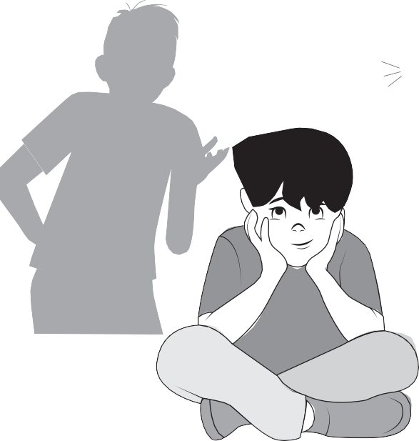

**agreement.**

* Sentences could be simple or a compound. A **simple sentence** consists of one independent clause. A **compound sentence** consists of two or more independent clauses.
* A **reflexive pronoun** tells us that whoever performs the action in a sentence is also the one on the receiving end of that action. An **intensive pronoun** emphasizes the preceding noun.



“

DON’T FORGET

•

All sentences, to be considered complete, must have a subject and a verb. But don’t forget the grammar rule that states that subjects and verbs must agree with each other in number. This is known as the **subject-verb**

## REACH THE TOP



**Opposing Viewpoints.** Have you encountered people who have really ridiculous opinions such as, “I really think the world is flat”, or “I know aliens built the pyramids.” Do you just leave them alone? How about countering their claims? How do you counter their claims? How do you oppose their viewpoints?

EXPLORE MORE

**Express Yourself.** Express what you honestly feel about the topics and lessons in this English Communication Learner’s Book. Are they too difficult? Are they difficult but manageable? Do you find them useful? (We hope you do.) Start expressing yourself with start-up signal phrases such as “I believe,” “I feel,” or “I really think,” etc. You may include an intensive pronoun, making it “I myself believe,” “I myself feel,” or “I myself truly think,” etc.

LESSON 1: WHAT IS THE SUBJECT, PLEASE?

TRYING THIS OUT

PAGE 4

ACTIVITY I

1. S - Anger

V - increases

1. S - Fred

V - learned

1. S - Time V - is
2. S - The newly registered voters V - exercise
3. S - I

V - am

ACTIVITY II

**1.** T

**2.** F

**3.** F

**4.** T

**5.** T

UNDERSTANDING WHAT YOU DID

ACTIVITY

PAGE 6

1. **S** = Helping others / **V** = is
2. **S** = I / **V** = believe
3. **S** = They / **V** = are
4. **S** = We / **V** = are
5. **S** = You / **V** = want

SHARPENING YOUR SKILLS

ACTIVITY I

1. **S** = Disagreement / **V** = is
2. **S** = the girls / **V** = are having
3. **S** = I / **V** = win
4. **S** = The game / **V** = is
5. **S** = You / **V** = believe

PAGE 9

ACTIVITY II

|  |  |  |
| --- | --- | --- |
| **1.** help | **6.** play | **1.** see |
| **2.** likes | **7.** does | **2.** come |
| **3.** live | **8.** do | **3.** is |
| **4.** see | **9.** is | **4.** Do |
| **5.** is | **10.** have | **5.** do |

TREADING THE ROAD TO MASTERY

**Sentence 1:** My mother (subject), likes (verb) **Sentence 2:** They (subject), talk (verb) **Sentence 3:** My father (subject(, needs (verb)

LESSON 2: IT’S SIMPLY ACTIVE

TRYING THIS OUT

PAGE 10

PAGE 12

ACTIVITY I

* 1. Simple
  2. Compound
  3. Compound
  4. Simple
  5. Simple

ACTIVITY II

1. Passive
2. Passive
3. Active
4. Passive
5. Active

UNDERSTANDING WHAT YOU DID

ACTIVITY I

1. the glass
2. someone
3. my car
4. a special dish
5. an e-mail

ACTIVITY II

1. The flat tire was changed (by Benito).
2. Bamboo trees are planted (by us) along the watershed.
3. A movie will be watched (by us) tonight.
4. The newspaper was read quickly (by my mother).
5. The house is cleaned (by me) on Saturday.

PAGE 21

PAGE 24

SHARPENING YOUR SKILLS

ACTIVITY I

* 1. You can come here and watch the show with us or …
     + you can go outside and play.
  2. She kept redoing her homework but still …
     + she could not get it right.
  3. You can do it this way or …
     + you can do it that way.
  4. We were so noisy in class but the teacher …
     + continued with the lessons.
  5. He is now a famous celebrity and yet …
     + he is still as humble and nice as before.

ACTIVITY II

1. **Passive voice:** The movie was seen (by us) yesterday.
2. **Passive voice:** The passenger jeepney was driven (by my uncle) today.
3. **Passive voice:** You are loved (by me).
4. **Passive voice:** The cellphone was kept (by Henry) in the drawer.
5. **Passive voice:** Her breakfast was taken early.

TREADING THE ROAD TO MASTERY

1. SS
2. CS
3. CS
4. SS
5. CS

PAGE 22

PAGE 23

LESSON 3: YOU ARE SO INTENSE

TRYING THIS OUT

ACTIVITY I

1. herself (reflexive pronoun)
2. itself (reflexive pronoun)
3. myself (intensive pronoun)
4. themselves (reflexive pronoun)
5. himself (intensive pronoun

ACTIVITY II

Answer the following by giving a reason: ***Open-ended answers.***

1. Do you think mining does more good than harm?
2. Do you believe in the effectiveness of virgin coconut oil?
3. Should senior citizens get even bigger discounts?

UNDERSTANDING WHAT YOU DID

ACTIVITY I

1. I ***myself*** will look into the problem.
2. Why don’t you buy ***yourself*** some candies?
3. They know ***themselves*** better than we do.
4. Why don’t we just enjoy ***ourselves*** today?
5. She sees ***herself*** in you.

ACTIVITY II

***Suggested answers***

1. you will no longer attend the meetings.
2. it was an honest mistake.
3. solves the problem.
4. you will help me.
5. she will no longer return to pick us up.

PAGE 25

PAGE 29

PAGE 32

SHARPENING YOUR SKILLS

ACTIVITY I

* 1. myself
  2. yourself
  3. themselves
  4. herself
  5. ourselves

ACTIVITY II

1. to explain themselves on what happened.
2. be punished for what the customers did.
3. should be given the full benefits.
4. help their country during crucial times.
5. I don’t think so.

TREADING THE ROAD TO MASTERY

Suggested answers

1. Athena herself thinks she is a goddess.
2. The student body itself feels the need to launch a new project.
3. Johnny himself wants a guitar.
4. I myself find her views outrageous.
5. Mother and father themselves want a vacation.

PAGE 33

PAGE 34

## GLOSSARY

Active Voice

Compound Sentence

Intensive Pronouns

Passive Voice

Reflexive Pronouns

Simple Sentence

Subject

When a sentence is in active voice, the subject of the sentence performs the action of the verb.

A *compound sentence* is made up of two or more independent clauses connected by coordinating conjunctions.

These are pronouns that come before a noun for emphasis.

When a sentence is in passive voice, the sentence focuses on the object and the action performed on it.

This is a pronoun that indicates that whoever performs the action is also the one receiving said action.

A *simple sentence* consists of one independent clause.

A *subject* is a person or thing that is being described in the sentence, usually the doer of the action.

Subject-verb Agreement

Verb

This is the rule that states that subjects and verbs must agree with each other in number.

This is the action the person or thing performs or the description of the person or thing.

The development and printing of this learning resource was made possible with the cooperation of Asia Paciflc College. This is a component of the project “Better Life for Out-of-School Girls to Fight Against Poverty and Injustice in the Philippines” implemented by UNESCO Office, Jakarta in partnership with the Department of Education. This initiative received a generous flnancial support from Korea International Cooperation Agency (KOICA).

For inquiries, please contact:

Department of Education, Bureau of Learning Resources (DepEd BLR)

Office Address : Ground Floor, Bonifacio Building, DepEd Complex,

Meralco Avenue, Pasig City, Philippines 1600

Telefax : +63-2-8631-1072; +63-2-8634-1054; +63-2-8631-4985

Email Address : blr.qad@deped.gov.ph; [blr.lrpd@deped.gov.ph](mailto:blr.lrpd@deped.gov.ph)